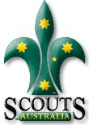
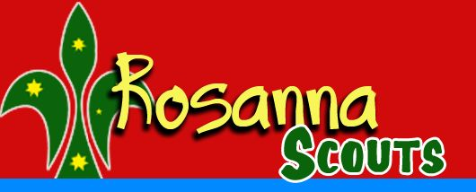

Rosanna Cubs & Scouts –
Ivanhoe RSL
Wednesday 6th June

On Wednesday, the 6th, we’re going to meet at Ivanhoe RSL to learn about “Their Service – Our Heritage” as part of earning the Heritage Badge.

Note… NO CUBS on Tuesday the 5th!

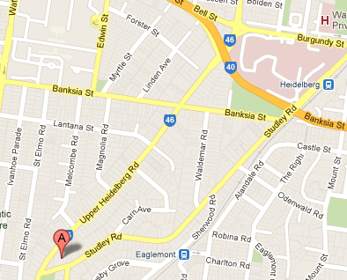
Details:
- Meet at Ivanhoe RSL, 3-5 Studley Rd, Ivanhoe at 7:00 pm sharp.
- Pickup from the RSL at the conclusion from 8:15pm.
Cubs and Scouts will be learning about the service of our Service men and women.

For those who also attended Anzac Day Services, these will complete their Heritage Badge requirements. For others, this will cover half the badge and we can sort out the requirements for the rest.
Melway Ref: 31 G6

See you there – don’t miss it!


Akela & Michelle
9434 7594
0411 121 495
akela@rosannacubs.org
michelle@rosanascouts.org

